
CLIENT ID: DOJ:
NAME: AGE/GENDER:
ORGANIZATION: DEPARTMENT:
MOBILE: DOS:

Height: |  | IBW: |  | SMR:
EHR: |  | LBW: |  | Target Calorie:
EHR: Exercise heart rate, IBW: Ideal body weight, LBW: Lean body weight, SMR: Sedentary metabolic rate
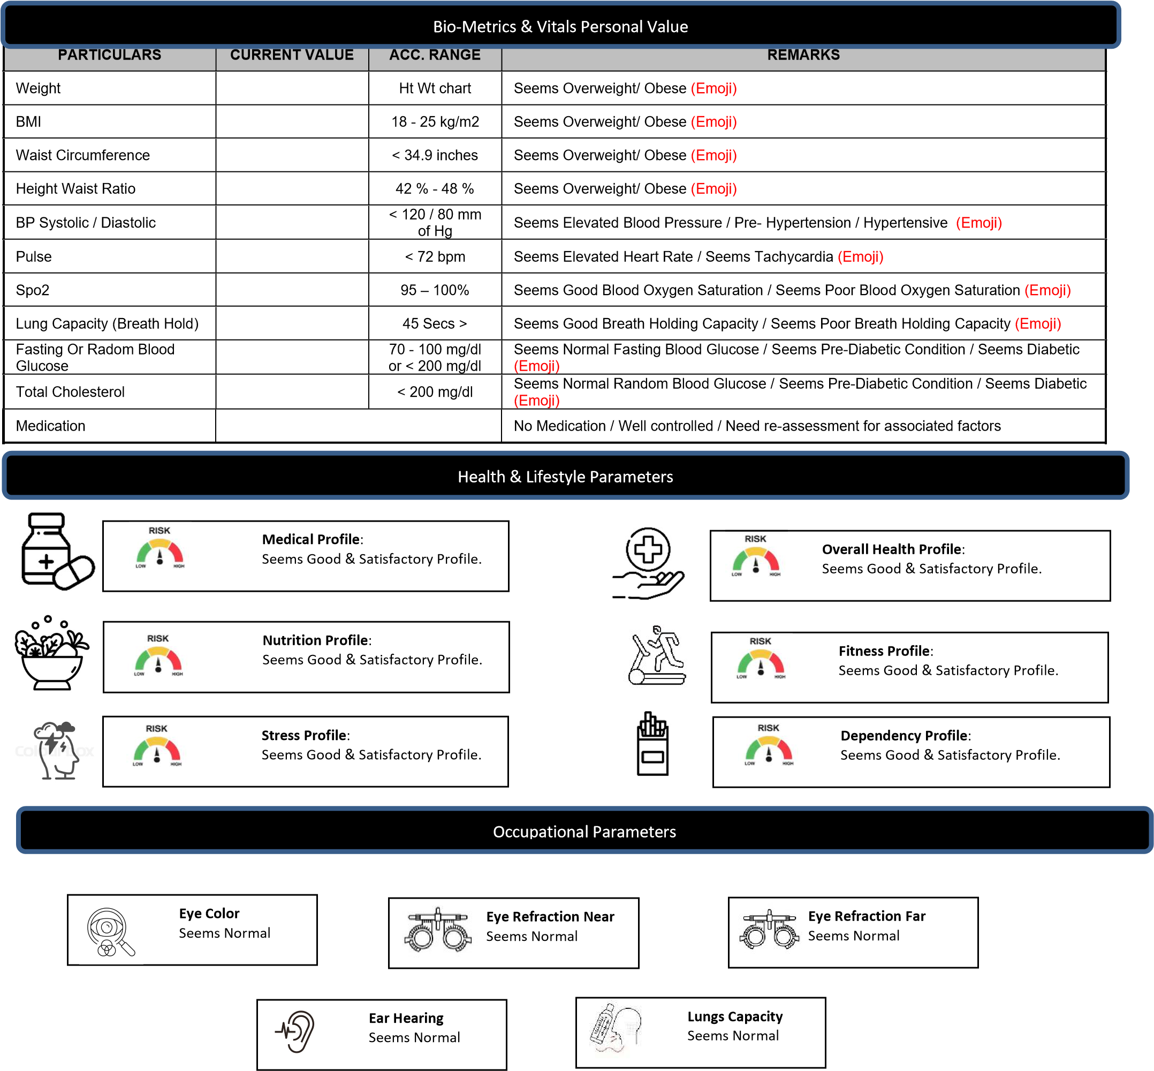

Disclaimer: (Displayed on the bottom of first page of CWP health report) The Health Risk Evaluation Tool (HRET) provides an indication of your current health status based on the information you provide. It offers preliminary insight into potential health risks and chronic disease complications and does not replace medical evaluation or a doctor’s advice.

